Last reviewed:

Safeguarding Policy and Procedure
(Including Safer Recruitment Policy)

Introduction
This policy aims to provide all members of staff (paid and unpaid), children and young people, and their families with a clear and secure framework for ensuring that all children who use our service are protected from harm, both during sessions.
Croydon Boxing Academy believes that safeguarding and promoting the welfare of children is everyone’s responsibility. Every member of staff (which includes volunteers) who comes into contact with children and their families has a role to play in safeguarding children. In order to fulfill this responsibility, every member of staff is instructed to take a “Child Centered” approach, considering at all times what is in the best interests of the child.
Croydon boxing academy will ensure that all children are safeguarded by actively encouraging members of staff to work together proactively with children and families who may need help, and for this to happen as soon as possible so that children are protected from any further emotional and physical harm.

Aims
To ensure our safeguards and promotes the welfare of all children, we are committed to achieving the following aims:
- To provide all staff (including volunteers) with the necessary training to enable them to identify children who may be at risk and need to be safeguarded;
- To ensure all our policies, procedures and practices are designed with regard to Child Protection, ensuring compliance and consistency across our organisation;
- To seek opportunities to work together with those voluntary and statutory services who share our commitment in Child Protection;

Key Contacts
Position | Name | Contact Details (email/phone)
Designated Safeguarding Lead/Club Welfare Officer | Kamilah Vidale-Ellis | kamilahvidale@hotmail.com
Deputy Designated Safeguarding Lead/Deputy Club Welfare Officer | Shane Sobers | Shanesobers@hotmail.com

Roles and Responsibilities
All members of staff (including volunteers) within Croydon Boxing academy have a role to play in safeguarding and promoting the welfare of children. Specific members of staff also have additional roles and responsibilities too. This section outlines our expectations of our staff.

All Members of Staff …
- Have a responsibility to provide a safe environment in which children can learn;
- Who become concerned about a child’s welfare should follow the processes;
- Should receive appropriate safeguarding and child protection training which is regularly updated. In addition all staff members should receive early help and child protection updates (for example, via email, e-bulletins and staff meetings), as required, but at least annually, to provide them with relevant skills and knowledge to safeguard children effectively;
- Should know what to do if a child tells them he/she is being abused or neglected; Staff should know how to manage the requirement to maintain an appropriate level of confidentiality whilst at the same time liaising with relevant professionals such as the designated safeguarding lead. Staff should never promise a child that they will not tell anyone about an allegation- as this may ultimately not be in the best interests of the child;
- Should be aware of the signs of abuse and neglect so that they are able to identify cases of children who may be in need of help or protection. Types of abuse and neglect, and examples of safeguarding issues are described on pages below.
- Are advised to maintain an attitude of ‘it could happen here’ where safeguarding is concerned. When concerned about the welfare of a child, staff members should always act in the best interests of the child;
- Should always speak to the designated safeguarding lead if they are unsure about identifying abuse and neglect;
- Should maintain records about any concerns they have about a child.

The Designated Safeguarding Lead (Also known as Club Welfare Officer – CWO)…
- Is an appropriate member of staff from the board of trustees;
- Is supported by a Deputy Designated Safeguarding Lead;
- Takes lead responsibility for Safeguarding and Child Protection;
- Liaises with the Local Council (Croydon) and works with other authorised agencies
- (And or the deputy) should be available for staff by either direct or indirect contact to discuss any safeguarding concerns;
- Undergoes training to provide them with the knowledge and skills required to carry out the role. The training should be updated every two years;
- Keeps written records of all concerns when noted and reported by staff or when disclosed by a child, ensuring that such records are stored securely and reported onward in accordance with this policy guidance, but kept separately from the child’s general file;
- Ensures that all staff sign to indicate that they have read and understood this policy;
- Ensures that the child protection policy is updated annually;
- Keeps a record of staff attendance with regards to safeguarding & child protection training;
- Makes this policy available to parents/carers;
The Deputy Designated Safeguarding Lead is appropriately trained and, in the absence of the designated person, carries out those functions necessary to ensure the ongoing safety and protection of children. In the event of the long-term absence of the designated person, the deputy will assume all of the functions above.

Types of Abuse and Neglect and Specific Safeguarding Concerns
All members of staff should be aware that abuse, neglect and safeguarding issues are rarely standalone events that can be covered by one definition or label. In most cases multiple issues will overlap with one another. Individual indicators will rarely, in isolation, provide conclusive evidence of abuse. They should be viewed as part of a jigsaw, and each small piece of information will help the Designated Safeguarding Lead to decide how to proceed. It is very important that members of staff report concerns – they do not need ‘absolute proof’ that the child is at risk.

Abuse
A form of maltreatment of a child. Somebody may abuse or neglect a child by inflicting harm or by failing to act to prevent harm. Children may be abused in a family or in an institutional or community setting by those known to them or, more rarely, by others (e.g. via the internet). They may be abused by an adult or adults or another child or children.

Physical Abuse
A form of abuse which may involve hitting, shaking, throwing, poisoning, burning or scalding, drowning, suffocating or otherwise causing physical harm to a child. Physical harm may also be caused when a parent or carer fabricates the symptoms of, or deliberately induces, illness in a child.
Bumps and bruises don’t necessarily mean a child is being physically abused – all children have accidents, trips and falls.
There’s isn’t one sign or symptom to look out for that will say a child is definitely being physically abused. But if a child often has injuries, there seems to be a pattern, or the explanation doesn’t match the injury then this should be investigated.
Bruises | Burns or Scalds | Bite Marks
- commonly on the head but also on the ear or neck or soft areas - the abdomen, back and buttocks | - can be from hot liquids, hot objects, flames, chemicals or electricity | - usually oval or circular in shape
- defensive wounds commonly on the forearm, upper arm, back of the leg, hands or feet | - on the hands, back, shoulders or buttocks; scalds may be on lower limbs, both arms and/or both legs | - visible wounds, indentations or bruising from individual teeth.
- clusters of bruises on the upper arm, outside of the thigh or on the body | - a clear edge to the burn or scald
- bruises with dots of blood under the skin | - sometimes in the shape or an implement for example, a circular cigarette burn
- a bruised scalp and swollen eyes from hair being pulled violently | - multiple burns or scalds.
- bruises in the shape of a hand or object.
Fractures or Broken Bones | Other Injuries & Health Problems
- fractures to the ribs or the leg bones in babies | - scarring
- multiple fractures or breaks at different stages of healing | - effects of poisoning such as vomiting, drowsiness or seizures
 | - respiratory problems from drowning, suffocation or poisoning

Emotional Abuse
The persistent emotional maltreatment of a child such as to cause severe and adverse effects on the child’s emotional development. It may involve conveying to a child that they are worthless or unloved, inadequate, or valued only insofar as they meet the needs of another person. It may include not giving the child opportunities to express their views, deliberately silencing them or ‘making fun’ of what they say or how they communicate. It may feature age or developmentally inappropriate expectations being imposed on children. These may include interactions that are beyond a child’s developmental capability as well as overprotection and limitation of exploration and learning, or preventing the child participating in normal social interaction. It may involve seeing or hearing the ill-treatment of another. It may involve serious bullying (including cyberbullying), causing children frequently to feel frightened or in danger, or the exploitation or corruption of children. Some level of emotional abuse is involved in all types of maltreatment of a child, although it may occur alone.
There often aren’t any obvious physical symptoms of emotional abuse or neglect but you may spot signs in a child's actions or emotions.

Changes in emotions are a normal part of growing up, so it can be really difficult to tell if a child is being emotionally abused.

Young children who are being emotionally abused or neglected may:
- Be overly-affectionate towards strangers or people they haven’t known for very long
- Lack confidence or become wary or anxious
- Not appear to have a close relationship with their parent, e.g. when being taken to or collected from nursery etc.
- Be aggressive or nasty towards other children and animals.

Older children may:
- Use language, act in a way or know about things that you wouldn’t expect them to know for their age
- Struggle to control strong emotions or have extreme outbursts
- Seem isolated from their parents
- Lack social skills or have few, if any, friends.

Sexual Abuse
Involves forcing or enticing a child or young person to take part in sexual activities, not necessarily involving a high level of violence, whether or not the child is aware of what is happening. The activities may involve physical contact, including assault by penetration (for example rape or oral sex) or non-penetrative acts such as masturbation, kissing, rubbing and touching outside of clothing. They may also include non-contact activities, such as involving children in looking at, or in the production of, sexual images, watching sexual activities, encouraging children to behave in sexually inappropriate ways, or grooming a child in preparation for abuse (including via the internet). Sexual abuse is not solely perpetrated by adult males. Women can also commit acts of sexual abuse, as can other children.
Children who are sexually abused may:
Stay away from certain people | Show sexual behaviour that's inappropriate for their age | Have physical symptoms
- they might avoid being alone with people, such as family members or friends | - a child might become sexually active at a young age | - anal or vaginal soreness
- they could seem frightened of a person or reluctant to socialise with them. | - they might be promiscuous | - an unusual discharge
 | - they could use sexual language or know information that you wouldn't expect them to. | - sexually transmitted infection (STI)
 |  | - pregnancy.

Neglect
The persistent failure to meet a child’s basic physical and/or psychological needs, likely to result in the serious impairment of the child’s health or development. Neglect may occur during pregnancy as a result of maternal substance abuse. Once a child is born, neglect may involve a parent or carer failing to: provide adequate food, clothing and shelter (including exclusion from home or abandonment); protect a child from physical and emotional harm or danger; ensure adequate supervision (including the use of inadequate care-givers); or ensure access to appropriate medical care or treatment. It may also include neglect of, or unresponsiveness to, a child’s basic emotional needs.
Neglect can be really difficult to identify, making it hard for professionals to take early action to protect a child. Having one of the signs or symptoms below doesn't necessarily mean that a child is being neglected. But if you notice multiple, or persistent, signs then it could indicate there’s a serious problem.

Children who are neglected may have:

Poor Appearance and Hygiene Issues | Housing and Family Issues
- be smelly or dirty | - living in an unsuitable home environment for example dog mess being left or not having any heating
- have unwashed clothes | - left alone for a long time
- have inadequate clothing, e.g. not having a winter coat | - taking on the role of carer for other family members.
- seem hungry or turn up to school without having breakfast or any lunch money
- have frequent and untreated nappy rash in infants.
Health and Development Problems
- untreated injuries, medical and dental issues | - skin sores, rashes, flea bites, scabies or ringworm
- repeated accidental injuries caused by lack of supervision | - thin or swollen tummy
- recurring illnesses or infections | - anaemia
- not been given appropriate medicines | - tiredness
- missed medical appointments such as vaccinations | - faltering weight or growth and not reaching developmental milestones (known as failure to thrive)
- poor muscle tone or prominent joints | - poor language, communication or social skills.

Bullying (Including Online Bullying)
While bullying between children is not a separate category of abuse and neglect, it is a very serious issue that can cause considerable anxiety and distress. At its most serious level, bullying is thought to result in up to 12 child suicides each year. All incidences of bullying should be reported and will be managed through our behaviour and anti-bullying procedures. All pupils and parents receive a copy of the anti-bullying procedures on joining the school and the subject of bullying is addressed at regular intervals in the personal, social and health education (PSHE) curriculum. If the bullying is particularly serious, or the anti-bullying procedures are deemed to be ineffective, the head teacher and the DSP will consider implementing child protection procedures.
A child may be experiencing abuse online if they:
- Spend lots, much more or much less time online, texting, gaming or using social media
- Are withdrawn, upset or outraged after using the internet or texting
- Are secretive about who they’re talking to and what they’re doing online or on their mobile phone
- Have lots of new phone numbers, texts or e-mail addresses on their mobile phone, laptop or tablet.

Specific Safeguarding Issues
Children are also impacted by specific safeguarding issues, which are events which encompass all of the above types of abuse. These issues are further compounded by children exhibiting behaviours such as drug taking, alcohol abuse, absence from school, and sexting. Peer on Peer abuse is also an indicator that children may be exposed to bullying (including online bullying), gender based violence/sexual abuse and sexting. Members of staff will challenge peer on peer abuse in conjunction with the Designated Safeguarding Lead, Local Authority, Police and Parent/Carers.

Child Sexual Exploitation
Child sexual exploitation is a form of sexual abuse where children are sexually exploited for money, power or status. It can involve violent, humiliating and degrading sexual assaults. In some cases, young people are persuaded or forced into exchanging sexual activity for money, drugs, gifts, affection or status. Consent cannot be given, even where a child may believe they are voluntarily engaging in sexual activity with the person who is exploiting them. Child sexual exploitation does not always involve physical contact and can happen online. A significant number of children who are victims of sexual exploitation go missing from home, care and education at some point. Some of the following signs may be indicators of sexual exploitation:
- Children who appear with unexplained gifts or new possessions;
- Children who associate with other young people involved in exploitation;
- Children who have older boyfriends or girlfriends;
- Children who suffer from sexually transmitted infections or become pregnant;
- Children who suffer from changes in emotional well-being;
- Children who misuse drugs and alcohol;
- Children who go missing for periods of time or regularly come home late
Referrals in relation to concerns of CSE can be discussed via the local social services.

Female Genital Mutilation (FGM) and so-called “Honour Based” Violence (HBV)
So-called ‘honour-based’ violence (HBV) encompasses crimes which have been committed to protect or defend the honour of the family and/or the community, including Female Genital Mutilation (FGM), forced marriage, and practices such as breast ironing. All forms of so called HBV are abuse (regardless of the motivation) and should be handled and escalated as such. If in any doubts staff should speak to the Designated Safeguarding Lead.
There are a range of potential indicators that a child may be at risk of HBV. Guidance on the warning signs that FGM or forced marriage may be about to take place, or may have already taken place, can be found on pages 38-41 of the Multi agency statutory guidance on FGM (pages 59-61 focus on the role of schools and colleges) and pages 13-14 of the Multi-agency guidelines: Handling case of forced marriage.
FGM comprises all procedures involving partial or total removal of the external female genitalia or other injury to the female genital organs. It is illegal in the UK and a form of child abuse with long-lasting harmful consequences.
Section 5B of the Female Genital Mutilation Act 2003 (as inserted by section 74 of the Serious Crime Act 2015) places a statutory duty upon teachers along with regulated health and social care professionals in England and Wales, to report to the police where they discover (either through disclosure by the victim or visual evidence) that FGM appears to have been carried out on a girl under 18. Those failing to report such cases will face disciplinary sanctions. It will be rare for teachers to see visual evidence, and they should not be examining pupils, but the same definition of what is meant by “to discover that an act of FGM appears to have been carried out” is used for all professionals to whom this mandatory reporting duty applies.
The duty does not apply in relation to at risk or suspected cases (i.e. where the teacher does not discover that an act of FGM appears to have been carried out, either through disclosure by the victim or visual evidence) or in cases where the woman is 18 or over. In these cases, teachers should follow local safeguarding procedures.
A girl or woman who's had FGM may:
- Have difficulty walking, sitting or standing
- Spend longer than normal in the bathroom or toilet
- Have unusual behaviour after an absence from school or college
- Be particularly reluctant to undergo normal medical examinations
- Ask for help, but may not be explicit about the problem due to embarrassment or fear.

Referrals in relation to concerns can be discussed via the local social services.

Forced Marriage
Forcing a person into a marriage is a crime in England and Wales. A forced marriage is one entered into without the full and free consent of one or both parties and where violence, threats or any other form of coercion is used to cause a person to enter into a marriage. Threats can be physical or emotional and psychological. A lack of full and free consent can be where a person does not consent or where they cannot consent (if they have learning disabilities, for example). Nevertheless, some communities use religion and culture as a way to coerce a person into marriage. Parallel Youth Enterprise can play an important role in safeguarding children from forced marriage.

Preventing Radicalization
Protecting children from the risk of radicalization should be seen as part of wider safeguarding duties, and is similar in nature to protecting children from other forms of harm and abuse. During the process of radicalization it is possible to intervene to prevent vulnerable people being radicalized.
Radicalization refers to the process by which a person comes to support terrorism and forms of extremism. There is no single way of identifying an individual who is likely to be susceptible to an extremist ideology. It can happen in many different ways and settings.
Some examples of signs that a child may be at risk of radicalization are:
- Being overly secretive about their online viewing – for example this is one of the core ways in which ISIS is known to communicate and recruit.
- Displaying feelings of isolation or expressions of an ‘us and them’ mentality – a sign of the sense of social isolation.
- Becoming more argumentative or domineering in their viewpoints, being quick to condemn those who disagree and ignoring views that contradict their own.
- Questioning their faith or identity.
- Downloading or promotion extremist content.
- Social isolation – losing interest in activities they used to enjoy, distancing themselves from friends and social groups.
- Altered appearance – change in style of dress and/or personal appearance.
- Abnormal routines, travel patterns or aspirations.

Referrals in relation to concerns of PR can be discussed via the local social services.

Domestic Abuse and Sexual Violence, including Peer on Peer Abuse
The Government’s definition, amended in April 2013 to include 16 and 17 year olds, and coercive control is:

“Any incident or pattern of incidents of controlling, coercive or threatening behaviour, violence or abuse between those aged 16 or over who are or have been intimate partners or family members regardless of gender or sexuality. This can encompass, but is not limited to, the following types of abuse”:

Psychological
Physical
Sexual
Financial
Emotional

Domestic abuse and sexual violence can have a huge impact on affected children and young people. It can affect their safety, health and wellbeing, educational attainment, family and peer relationships, and their ability to enjoy healthy, happy, respectful relationships in the future. It is likely that there will be young people and staff within our school who are experiencing or perpetrating domestic abuse or sexual violence. Our school is responsible for making sure its learners and staff are safe and healthy.
It is important to always consider domestic and sexual abuse as a possible explanation for any unusual behaviour.
The following signs and symptoms can be warning signs that a child or young person is experiencing domestic and sexual abuse.

- Persistent absence from school | - Eating disorders | - Early/unwanted pregnancy | - Anxiety
- Decline in behaviour, performance and engagement | - Depression | - Evidence of control over movement | - Substance misuse
- Self-harm | - Isolation | - Evidence of being monitored by family or other adults | - Attempted suicide
- Evidence that certain situation trigger memories of traumatic experiences

The Club Welfare Officer will act as the first point of contact for any concerns about Domestic Abuse and Sexual Violence, including Peer on Peer Abuse.
Children with Disabilities
Studies suggest children with disabilities are at increased risk of abuse. Various factors contribute to this, such as; stereotyping, prejudice, discrimination, isolation and a powerlessness to protect themselves or adequately communicate that abuse has occurred.
Any child with a disability is by definition a 'child in need' under s17 of the Children Act 1989. Since the Disability Discrimination Act 1995 was repealed in 2011 by the Equality Act 2010 it remains unlawful to discriminate against a disabled person in relation to the provision of services. This includes making a service more difficult for a disabled person to access or providing them with a different standard of service. The Disability Discrimination Act 2005 (DDA) and the Equality Act 2010 define a disabled person as someone who has:
"a physical or mental impairment which has a substantial and long term adverse effect on his or her ability to carry out normal day to day activities"
This means that the needs of children and young people with long term illnesses such as leukaemia, diabetes, cystic fibrosis, or sickle cell are addressed. They may not usually be thought of as disabled, but their vulnerabilities may be similar. The key issue is the impact of abuse or neglect on a child or young person's health and development and how best to support them and safeguard their welfare.
All children/ young people who are identified to have SENs/disabilities should have a safeguarding concern form (Section B) completed by the reporting staff member or the child should be highlighted to the CWO for a form to completed and stored whilst the child is a member/attendee at the club.
Safeguards for disabled children are essentially the same as for non-disabled children. Particular attention should be paid to promoting a high level of awareness of the risks of harm and high standards of practice, and strengthening the capacity of children and families to help themselves. Measures should include:
- Making it common practice to help disabled children make their wishes and feelings known in respect of their care and treatment;
- Ensuring that disabled children receive appropriate personal, health, and social education
- Making sure that all disabled children know how to raise concerns, and giving them access to a range of adults with whom they can communicate. Those disabled children with communication impairments should have available to them at all times a means of being heard;
- An explicit commitment to, and understanding of disabled children's safety; and
- Welfare among providers of services used by disabled children;
- Close contact with families, and a culture of openness on the part of services;
- Guidelines and training for staff on good practice in intimate care; working with children of the opposite sex; handling difficult behaviour; consent to treatment;
- Anti-bullying strategies; and sexuality and sexual behaviour among young people, especially those living away from home; and
- Guidelines and training for staff working with disabled children aged 16 and over to ensure that decisions about disabled children who lack capacity will be governed by the Mental Health Capacity Act once they reach the age of 16.

Croydon Boxing Academy Guiding Principles
Croydon Boxing Academy is committed to ensuring everything possible is done to prevent the unnecessary escalation of issues or problems.
Our guiding principles are:
- Identification and intervention for all children who need it;
- Children and young people and their families are listened to, and details recorded in confidence;
- Safeguarding is everyone’s responsibility and the welfare of the child/young person is paramount.
Disclosures
Occasionally a child may disclose abuse themselves directly to an adult they trust.
Where this does happen the following should be considered:
- Do not pre-judge what you are told and never say that you do not believe what the child or young person says.
- Tell the child or young person that telling you is the correct thing to do.
- Tell the child or young person that they are not to blame.
- Do not under any circumstance continue to question the child or young person beyond confirming what they have said.
- Do not make promises to the child or young person that you cannot keep, for example - promising absolute confidentiality, as any disclosure will be referred on and other appropriate agencies may be involved.
- Do not take action against anyone mentioned in such disclosures and never against an alleged perpetrator.
- Take the child’s name, date of birth and address. (see appendix)
- If appropriate, take details of bruising or other injuries. (see appendix)
- In cases of immediate danger or threat, the emergency services should be called. Consideration should also be give as to whether the NCPCC should be called.
- In normal circumstances the referral to an outside agency will be carried out by the NCM however, in cases of emergency and in liaison with either the divisional / regional welfare officer and/or the NCM, the club welfare officer must contact the relevant agency (police/children’s social care services, etc.) This action should be treated as ‘immediate’.
- In all circumstances for avoidance of doubt guidance should always be sought from the divisional / regional welfare officer and/or the NCM

Child Protection Procedures

Taking Action
If staff members have any concerns about a child, the following process must be adopted:

Record Keeping
Record keeping is an essential part of child protection; it is vital that it is done accurately as soon after the event as possible and managed carefully and securely.
All records should be objective and accurate, be clear about names, dates, places etc. and also distinguish between fact and opinion, hearsay and direct information. Child Protection files should be in either a separate locked cabinet or on a separate Network Drive with access restricted to the Designated Safeguarding Lead/CWO (and their deputy) or any other authorised members or staff agreed by senior management.
Our Model Child Protection Folder can be found in at the end of this policy.

Confidentiality and sharing information
All members of staff understand that child protection issues warrant a high level of confidentiality, not only out of respect for the child and staff involved but also to ensure that being released into the public domain does not compromise evidence.
Staff should only discuss concerns with the designated person(s), (depending on who is the subject of the concern). That person will then decide who else needs to have the information and they will disseminate it on a ‘need-to-know’ basis.
Child protection information will be stored and handled in line with Data Protection Act 1998 principles. Information is:
- processed for limited purposes
- adequate, relevant and not excessive
- accurate
- kept no longer than necessary
- processed in accordance with the data subject’s rights
- secure.

Record of concern forms and other written information will be stored in a locked facility and any electronic information will be password protected and only made available to relevant individuals.

Safer Recruitment (In reference to Keeping Children Safe)

Recruitment, Selection and Pre-Employment Vetting
Croydon Boxing Academy is committed to a culture of safe recruitment and, as part of that, adopt recruitment procedures that help deter, reject or identify people who might abuse children. This part of the policy describes in detail those checks that are, or may be, required for any individual working in any capacity during sessions or other activities engaged by Croydon Boxing Academy The recruitment panel must act reasonably in making decisions about the suitability of any prospective employee based on checks and evidence including: criminal record checks (DBS checks), barred list checks and prohibition checks together with references and interview information.
For most appointments, an enhanced DBS certificate, which includes barred list information, will be required as the majority of staff will be engaging in activity.
A volunteer who regularly works with children may be required to undertake an enhanced DBS check. However, should this not be required, this volunteer will need to be supervised at all times and must not be left on their own with any children at any time.

Pre-appointment checks
Any offer of appointment made by Croydon Boxing Academy to a successful candidate, including one who has lived or worked abroad, will be conditional and only confirmed on satisfactory completion of the necessary pre-employment checks.
When appointing new staff, we will:
- request a minimum of 2 references, one of which must be the candidates current/previous employer and verify that these are to the school’s satisfaction;
- verify a candidate’s identity. Identification checking guidelines can be found on the GOV.UK website - https://www.gov.uk/government/publications/dbs-identity-checking-guidelines ;
- obtain (via the applicant) a certificate for an enhanced DBS check which will include barred list information, for those who will be engaging in regulated activity; - should there be positive disclosure/conviction then particular consideration will be require. This to involve an 1) enhanced pre-appointment process as a means to understand to full facts from the applicant and other professionals who need provide information and 2) the setting up of a recruitment panel to discuss and agree whether to proceed with this appointment. Should the appointment be proceeded with, then an in-depth risk assessment will need to be enacted.
- verify the person’s right to work in the UK. If there is uncertainty about whether an individual needs permission to work in the UK, we will follow the advice on the GOV.UK website; https://www.gov.uk/check-job-applicant-right-to-work
- if the person has lived or worked outside the UK, make any further checks we consider appropriate;
- verify all professional qualifications in relation to coaching/teaching / working with children.

Existing staff
If we have concerns about an existing staff member’s suitability to work with children, we will carry out all relevant checks as if the person were a new member of staff.
Apart from these circumstances, Croydon Boxing Academy will request a renewed DBS check every 3 years.
Volunteers
Under no circumstances will we allow a volunteer in respect of whom no checks have been obtained be left unsupervised or allowed to work in regulated activity.
Croydon Boxing Academy will undertake a risk assessment and use their professional judgement and experience when deciding whether to seek an enhanced DBS check for any volunteer. In doing so we will consider:
- the nature of the work with children;
- what we already know about the volunteer, including formal or informal information offered by staff, parents and other volunteers;
- whether the volunteer has other employment or undertakes voluntary activities where referees can advise on suitability; and
- whether the role is eligible for an enhanced DBS check.
When a Volunteer is being supervised:
- there must be supervision by a person leading the session/activity
- the supervision must be regular; and
- the supervision must be “reasonable in all the circumstances to ensure the protection of children”.

Visitors
Croydon Boxing Academy do not have the power to request DBS checks and barred list checks, or ask to see DBS certificates, for visitors (for example children’s’ relatives or other visitors attending sessions). However, visitors will be asking to leave the premises if it is deemed that they pose a risk.

Allegations of abuse made against staff

Duties as an employer and an employee
This part of the policy is about managing cases of allegations that might indicate a person would pose a risk of harm if they continue to work in regular or close contact with children in their present position, or in any capacity. It should be used in respect of all cases in which it is alleged against a member of staff (including volunteers) that has behaved in a way that has harmed a child, or may have harmed a child;
- possibly committed a criminal offence against or related to a child; or
- behaved towards a child or children in a way that indicates he or she would pose a risk of harm to children.
Croydon Boxing Academy has a duty to safeguard both the child (ren) and alleged member of staff and will take robust steps to mitigate and investigate the concerns raised. A risk assessment will be carried out while the serious consideration of removing the member of staff be achieved until full investigation has concluded. This investigation may have not involved the police and Children’s social care services should the allegation be of a serious nature.
Whistle Blowing
Any concerns for the welfare of any child arising from the abuse or harassment by a coach, volunteer or child / young person should be reported immediately. The welfare of the child must always be of paramount importance and, you should ensure someone takes immediate steps to remove the child or young person from a position of harm or potential harm.

If as a member of staff, a coach or other volunteer, you become aware that a member of staff, a coach or other volunteer has or may abuse a child/children, you MUST inform an appropriate person, in confidence if necessary. That person could be a club, divisional or regional welfare officer or the National Compliance Manager.

All information received and discussed will be treated in confidence and only shared with those individuals within Croydon Boxing Academy who will be able to manage and resolve the situation.

In urgent and serious case you MUST contact the police, the children’s social care services or the NSPCC. All these agencies are experienced in such matters and you can be confident that the concerns will be addressed in a professional way

Contact the Whistle Blowing Advice Line :08000280285
Email: help@nspcc.org.uk
Web: www.nspcc.org.uk/whistleblowing

Useful Contact information
Croydon SPOC/MASH
MASH assessment team telephone 0208726640/02082394307. This line is for urgent child protection matters only
For urgent calls OOH (17:00-09:00) please contact 02087266400/02087266000 and ask to speak to the OOH team
Email- childreferrals@croydon.gov.uk
Fax-02097269441
Consultation line-02087266464
If a child is immediately at risk call 999 immediately
Croydon Local authority Designated Officer (LADO)
(to refer concerns about a member of staff)
Steve Hall
Tel: 02082552889/07825830328
Email: steve.hall@croydon.gov.uk/LADO@croydon.gov.uk
Jane Parr (Assistant LADO)
Tel: 02082552889
Email: Jane.parr@croydon.gov.uk
Wandsworth Local Authority Designated Officer (LADO)
Chantel Langenhoven
Tel:02088717440
Email: LADO@wandsworth.gov.uk
ENGLAND BOXING

National Compliance Manager – Gordon Valentine 07590 600001 See EB website
For details of Regional Welfare Officer.

NSPCC Helpline: 0808 800 5000

NSPCC CPSU: www.thecpsu.org.uk 0116 234 7278

Sports coach UK
(for information on local courses including Safeguarding )

Sports coach UK, Chelsea Close, off Amberley Road, Armley, Leeds LS12 4HP

Tel: 0113 274 4802

www.sportscoachuk.org

Childline

Studd Street, London N1 0QV

Tel: 0800 1111

www.childline.org.uk

IF YOU ARE NOT SURE WHAT TO DO

Advice can be obtained by telephoning the NSPCC helpline on: 0800 800500

or Contact England Boxing on 0114 2235654

Annex A – Model Child Protection Folder

Strictly Confidential

Child Protection/safeguarding file for:
Full Name …….…………………………………………………………………………………………………………………………………………………………
Date of Birth………………………………………………………………………………………………………………………………………………………………
Address and tel.no ……………………………………………………………………………………………………………………………………
………………………………………………………………………………………………………………………………………………………………………………….
………………………………………………………………………………………………………………………………………………………………………………….

Chronology for ……………………………………………
Child protection files

(This should always be kept at the front of all CP documentation on each child’s
individual file)

Child’s name
Date of Birth

Incident and Significant Event Chronology: (number each separate sheet used)

Date | Brief Details | Source | Action | Outcome  (if known)

CAUSE FOR CONCERN REPORTING FORM

This form is to be completed on all occasions, at the time of observation, when there is cause for concern in relation to the welfare of a child and given to your Club Welfare Officer.

Name of Venue, Date & Time:

Name of Person reporting concerns
Post Held

Child Details:
Full Name
Date of Birth
Home Address
Post Code
Name of Parent/Carer (1)
Name of Parent/Carer (2)

Do these concerns related to a specific incident or event?
If YES complete Section A If NO complete Section B

Section A:
Date and Time of Incident
Place of Incident
Date Incident Recorded
Record completed by:
Please provide brief, factual account of circumstances of incident, to include any pre-existing, mitigating and/or aggravating factors and injuries sustained (if applicable, record on Body Map) – If you run out of space, use a continuation sheet including pupil details and page no)
CAUSE FOR CONCERN REPORTING FORM - CONTINUED
Witness Details – Include full name, whether adult or child and their role
Witness 1
Witness 2
Witness 3
Witness 4

Section B:
Please provide details of your concern(s), evidence base, professional opinion, nature of concern and actions taken

Any other relevant information:

Signed: |  | Dated:

Club Welfare Officer Signature: |  | Dated:

Action Taken by Club Welfare Officer:
NB: Child’s Child Protection Chronology must also be updated with a summary of this record

CAUSE FOR CONCERN REPORT: BODY MAP
Child Details:
Full Name |  | Date of Birth
Home Address
Post Code
Person completing Map
Date, time and place of observation
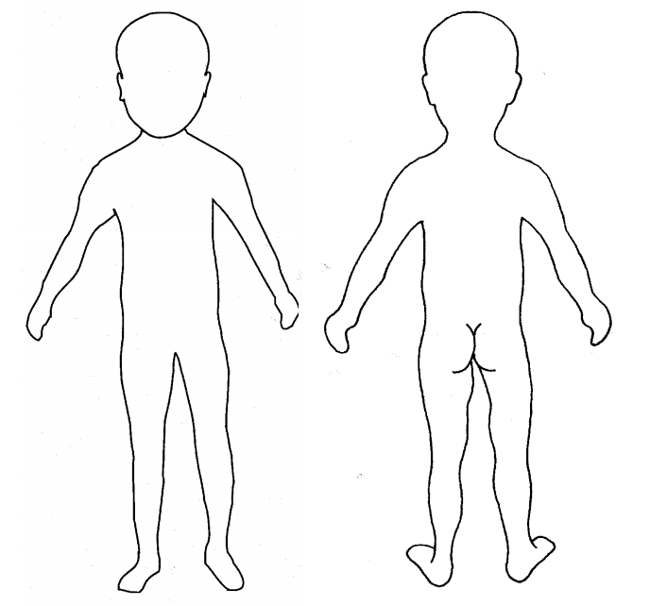

Child Details:
Full Name |  | Date of Birth
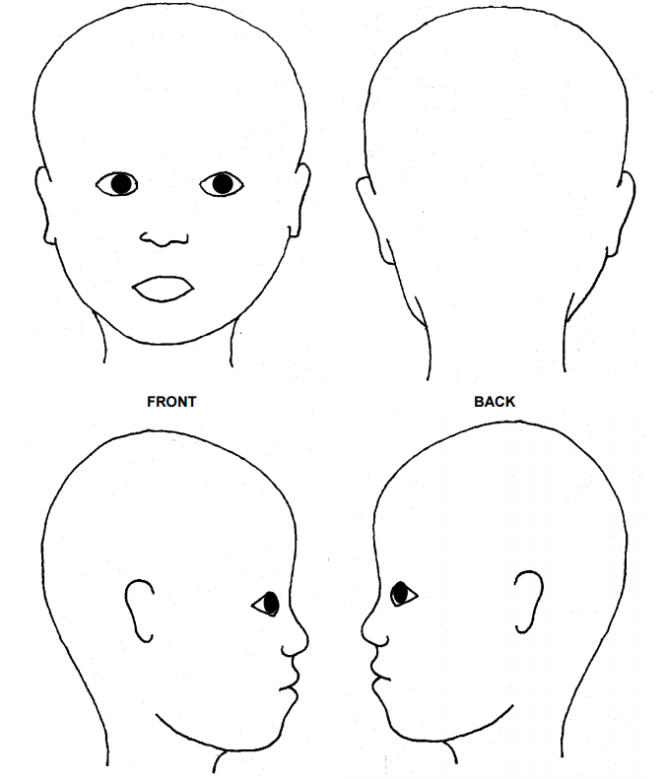

Child Details:
Full Name |  | Date of Birth
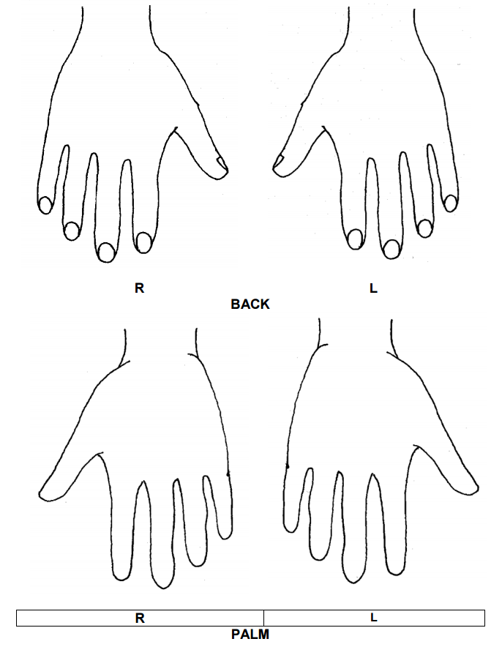

Child Details:
Full Name |  | Date of Birth
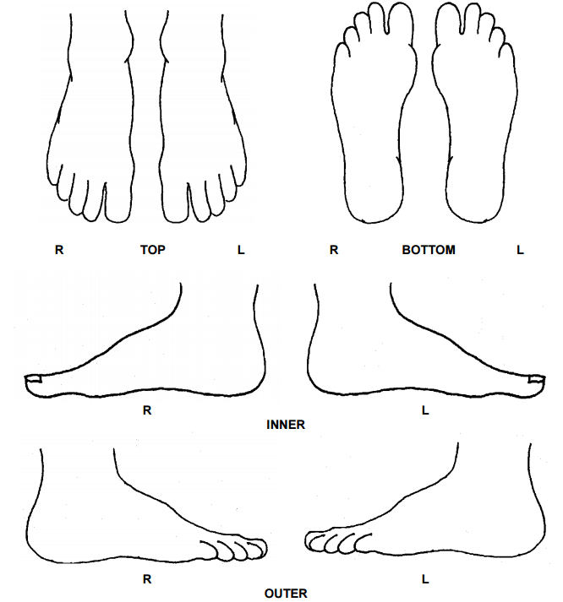

DBS Risk Assessment Form
To be used to assess the suitability of the applicant or member of staff for their proposed position, in light of matter(s) disclosed on their DBS Certificate.
Position Applied For:
Type of Disclosure: Enhanced
Date of Risk Assessment:
Risk Assessment undertaken by:
Please ensure that the Risk Assessment process form is completed in full and that a full account is given of any matters which have been disclosed.
SECTION A - Offence(s) Declared by Applicant
No. | Offence | Details and Date
1
2
3
4
SECTION B - Discussion between Assessor and Applicant
Question |  |  | (Please delete as  Applicable  appropriate) | Applicant Explanation/Comments
Did the applicant declare the matters on the DBS/CRB Disclosure Application form and/or the personal application form and or at interview? |  |  | Yes / No (if not why not)
Does the individual agree that the information detailed on the DBS/CRB Certificate is correct? |  |  | Yes / No (if not why not)
Does the individual regret the matter(s) or what is their attitude towards the matter now? |  |  | applicable  Yes / No /Not  Please explain
Would they do anything differently now? |  |  | applicable  Yes / No /Not  Please explain
Have the individual’s circumstances changed since the conviction? E.g. location, friends, partner, education? |  |  | applicable  Yes / No /Not  Please explain
Are there any mitigating circumstances? (E.g. peer pressure, financial need or lack of judgment) |  |  | applicable  Yes / No /Not  Please explain
Declaration by Applicant and any additional comments in support of their employment
Date: ……………………………….
I understand that any offer of employment will be subject to the information I have supplied and that this is complete and correct. False information, or a failure to supply the details required, could make an offer of employment invalid or lead to termination of employment.
Signature: ……………………………………..

